David J. Rodríguez Hernández

david.rodriguez@dnnsoftware.com

Recipes Bot

Implementing a Recipes bot service with Liquid Content

Table of Contents

Getting Started 3

Prerequisites 3

Setting Up the recipes 4

Step 1. Create the Recipes content type 4

Step 2. Create some recipes 4

Step 3. Generate an API Key to access the recipes 5

Creating the basic bot 6

Setup continuous integration 11

Enable continuous integration 11

Create an empty repository within a source control system 12

Download the source code for your bot 12

Choose the deployment source and connect your repository 12

Debugging the bot on your local environment 13

Prerequisites 13

Debug a C# bot using the Bot Framework Emulator 14

Debug a C# bot using breakpoints in Visual Studio 17

Customizing the basic bot 20

Modifying the source code 21

Setup the API Key settings 21

Adding the RootDialog.csx 23

Adding the HeroCardExtensions.csx 26

Adding the Recipes.csx 27

Adding the RecipeForm.csx 28

Test your Recipes bot 28

Test your bot locally 28

Test from other channels 29

Adding a webchat in your site 30

Enable your bot webchat 30

Create a webchat bot content type 31

Create a bot content item 31

Create a bot visualizer 32

Add the visualizer to a page 34

Known issues 35

Recipes bot

In this tutorial, you will build a recipes chat bot connecting your favorites message channels with Evoq Liquid ContentTM. The bot will be able to return a list of recipes for dinner after providing the list of ingredients you have.

The bot will be built by using the [Azure Bot Service](https://azure.microsoft.com/en-us/services/bot-service/), the intelligent, *serverless* bot service that scales on demand. With this service, you will be able to publish your bot through multiple channels without managing or patching any server. The service is [free](https://azure.microsoft.com/en-us/pricing/details/bot-service/), and you will only pay for the resources you consume.

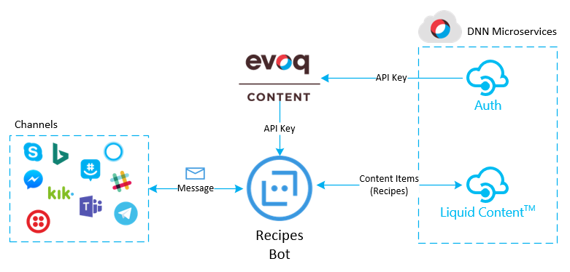

# Getting Started

## Prerequisites

To follow the tutorial, you will need:

* An active Azure subscription. You will need to login as owner of the subscription to host the bot service. You can sign up for a free subscription [here](https://azure.microsoft.com/free/).
* An Evoq Content or Engage site with Evoq Liquid Content enabled

Also, to debug your C# bot locally using breakpoints in Visual Studio you will need:

* Download and install the [Bot Framework Emulator](https://docs.microsoft.com/es-es/bot-framework/debug-bots-emulator).
* Install the [Azure Functions Core Tools](https://www.npmjs.com/package/azure-functions-core-tools).
* Install the [DotNet CLI](https://github.com/dotnet/cli).
* Download and install [Visual Studio 2017](https://www.visualstudio.com/downloads/) (Community Edition or above). (VS Code not supported for C# bots yet)
* Download and install the [Command Task Runner Visual Studio Extension](https://visualstudiogallery.msdn.microsoft.com/e6bf6a3d-7411-4494-8a1e-28c1a8c4ce99).
* Download the source code for your bot (from Azure), as described in **Set up continuous integration** section below. Complete previous steps first.

For more information about how to setup the debugging environment, visit [Debug with the emulator](https://docs.microsoft.com/es-es/bot-framework/debug-bots-emulator) and [Debug an Azure Bot Service C# bot](https://docs.microsoft.com/es-es/bot-framework/azure/azure-bot-service-debug-bot" \l "a-iddebug-csharpa-debug-a-c-bot) on the bot framework documentation.

# Setting Up the recipes

First, you need to setup the recipes model on Liquid Content by creating the Recipe content type and the recipes.

## Step 1. Create the Recipes content type

1. On the **Content Library > Content types** page, click on **Create Content Type** button
2. Create the following fields per the picture below:
   1. Name: Single Line Text (Required)
   2. Recipe Type: Multiple Choice (Required), and add the following choices: Starters, Breakfast, Salads, Soups, Main Courses, Sides, Desserts, Beverages
   3. Ingredients: Multi Line Text (Required)
   4. Instructions: Multi Line Text (Required)
   5. Picture Url: Line Text (Optional)
3. Click on **Save & Close** button

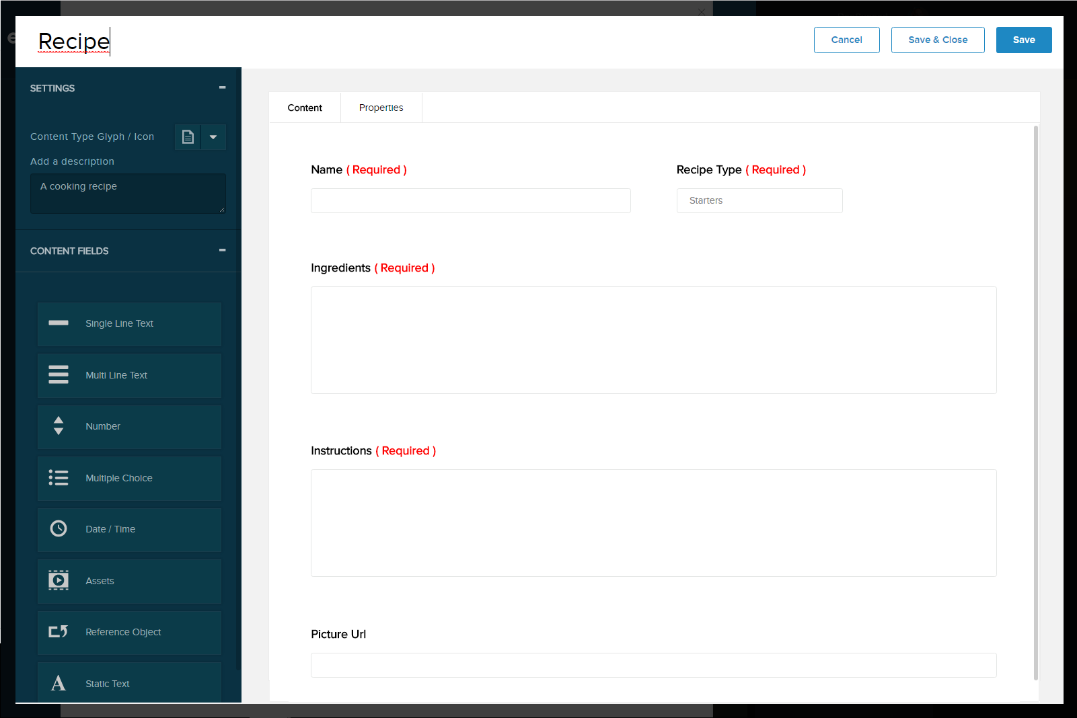

## Step 2. Create some recipes

Now that the Recipes content type has been created, we need to create some recipes to our content repository. You can add your own recipes, but for making this task easier, just go to <http://pinchmysalt.com/recipe-list/> and copy and paste some of your favorite recipes.

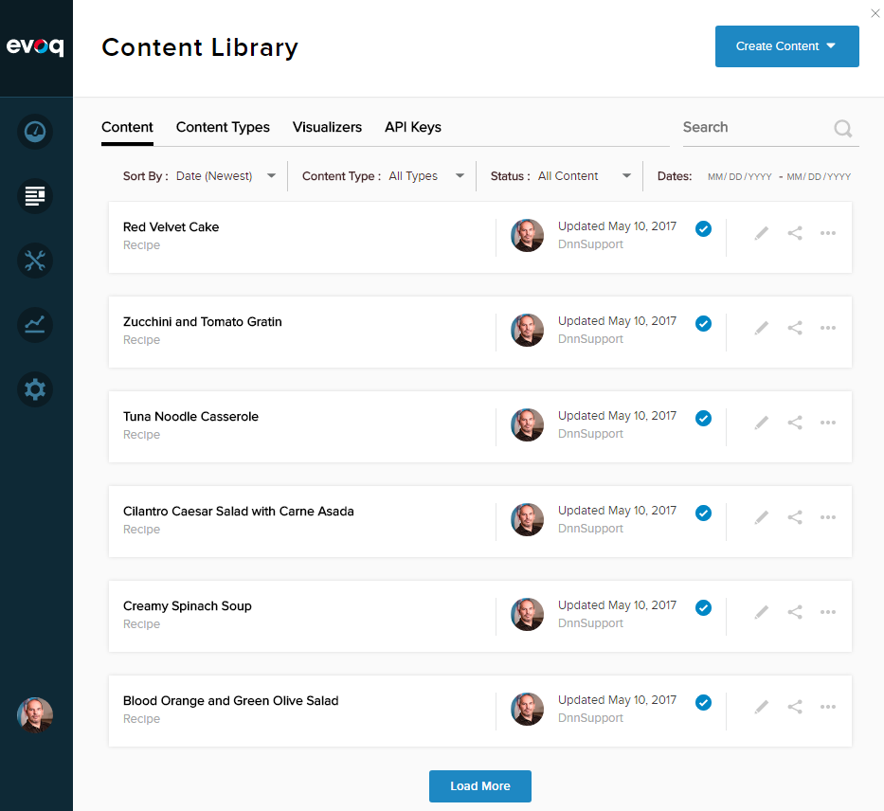

For each recipe, ensure you fill the following fields:

* Content Details:
  + Recipe Name
  + Recipe Type
  + Ingredients
  + Instructions
  + Picture Url (this is optional, but causes a cool effect 😊)
* Properties:
  + Content Item Name (use the same Recipe Name)
  + Description (recipe’s short description)

## Step 3. Generate an API Key to access the recipes

1. On the **Content Library > API Keys** page, click on the **Add New API Key** button
2. Type “Recipe bot” on the Name field
3. Enable **Read / Write Content Items**
4. Enable **Read Content Types**
5. Click on the **Create** button
6. The API Key will be generated. You will need this later to setup the bot service

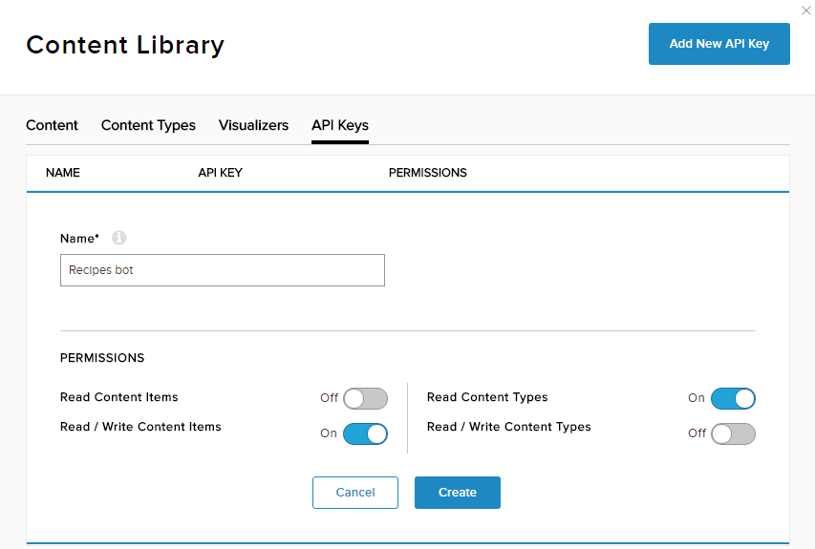

# Creating the basic bot

To create the bot using Azure Bot Service:

1. Sign in to [Azure](https://portal.azure.com/) portal
2. Select **New** in the menu blade
3. In the **New** blade, navigate to the Data + Analytics category, and select Bot Service.
4. In the Bot Service blade, provide the requested information and click **Create**. When the deployment completes, Azure adds a notification to the **Notifications** group.

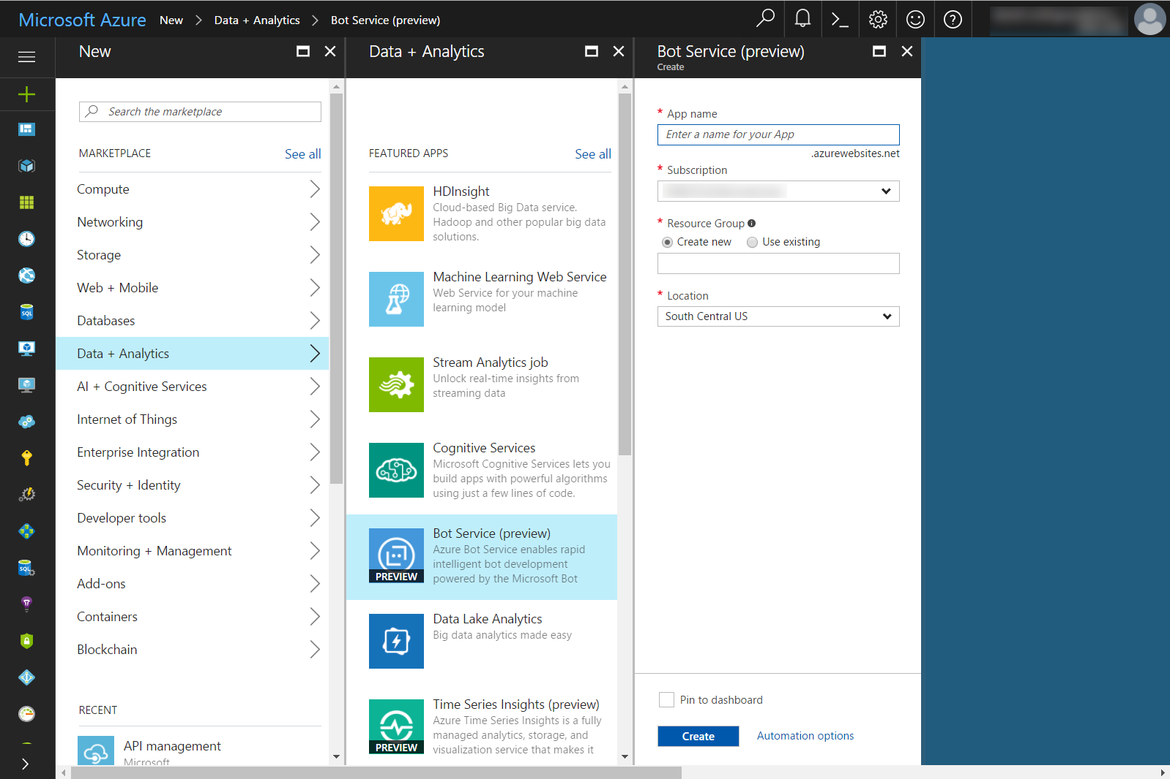

* Set **App name** to your bot’s name. The name is used as the subdomain of your deployment (for example, mydnnrecipesbot.azurewebsites.net). The name may contain alphanumeric characters and a dash (-).
* Select the subscription to use.
* Select the resource group and location. See the Azure documentation for information about [Resource Group](https://azure.microsoft.com/en-us/documentation/articles/resource-group-overview/), and [Location](https://azure.microsoft.com/en-us/regions/).

1. Check whether the bot has been deployed.
   * To determine whether the bot has been deployed, click **Notifications** (see the bell icon at the top right). The notification will change from **Deployments started** to **Deployments succeeded**.
   * Click on the notification to go to the bot resource

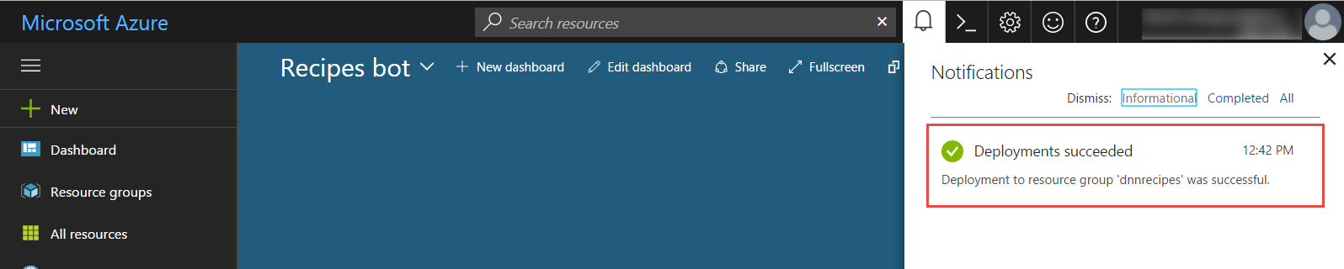

* + Alternatively, you can click All Resources in the menu blade, and then select the bot from the list of resources

1. Create an app ID and password by clicking **Create Microsoft App ID and password**.

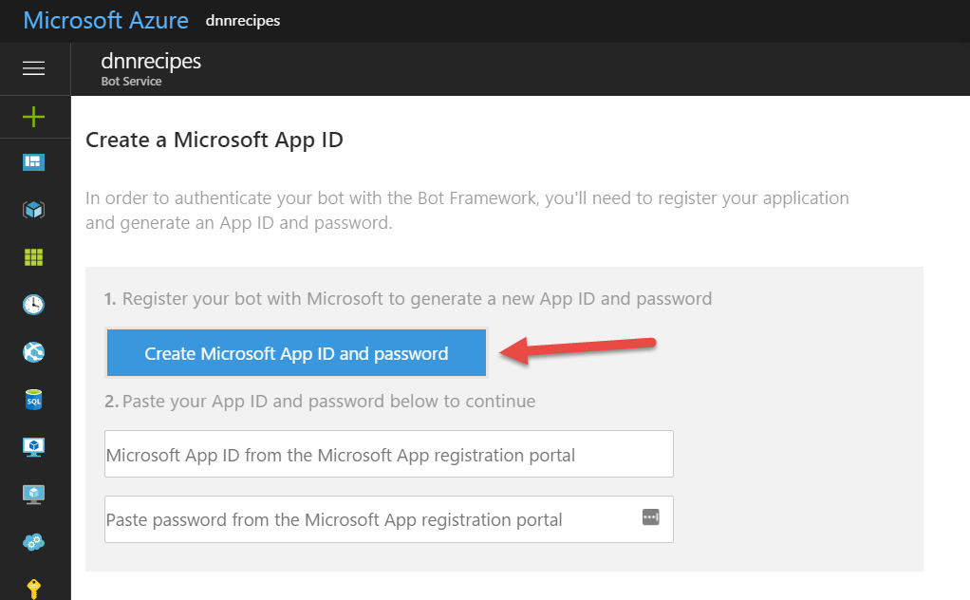

* + When you click Create, you’re taken to another page where you click **Generate an app password to continue** to get your password. Copy and securely store the password.
  + Click **Finish and go back to Bot Framework**.
  + When you come back, the app ID field is populated for you. Paste the password that you copied into the password field.

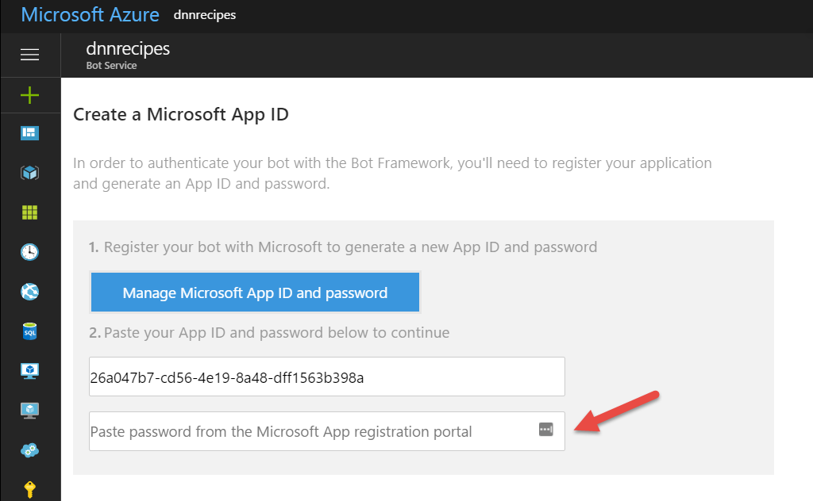

* + You should only click **Manage Microsoft App ID and password** if you want to get a secondary password for your bot. Note that you can manage passwords anytime in the Bot Framework portal. Click **My bots**, select the bot, and in the Details section, click **Edit**. Under Configuration, click **Manage Microsoft App ID and password**.

1. Select **C#** as the programming language to use to develop your bot.

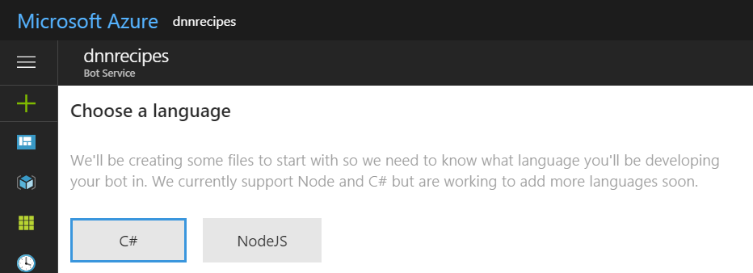

1. Select the **Basic** template to use as the starting point for writing the Recipes bot

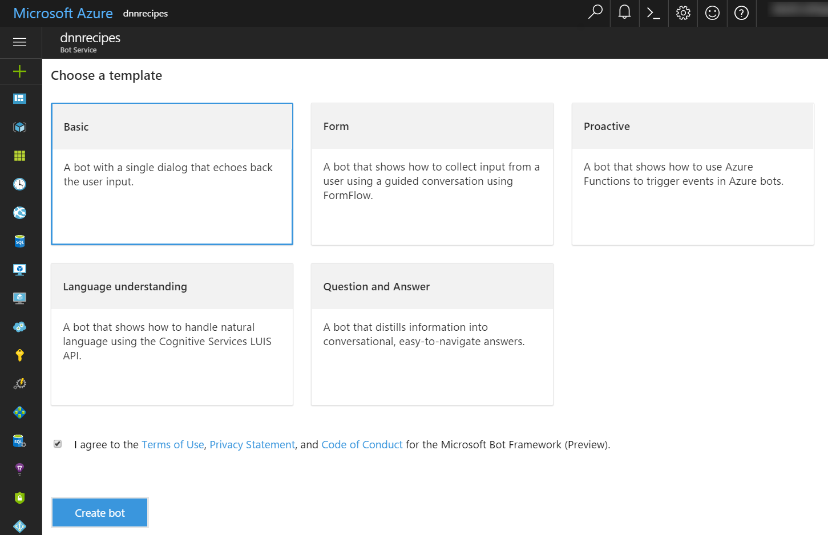

1. Click **Create bot** to create the bot. After the Bot Service generates your bot, the Azure editor will contain your bot’s source files. At this point, the bot is functional. Try it out in the chat control.

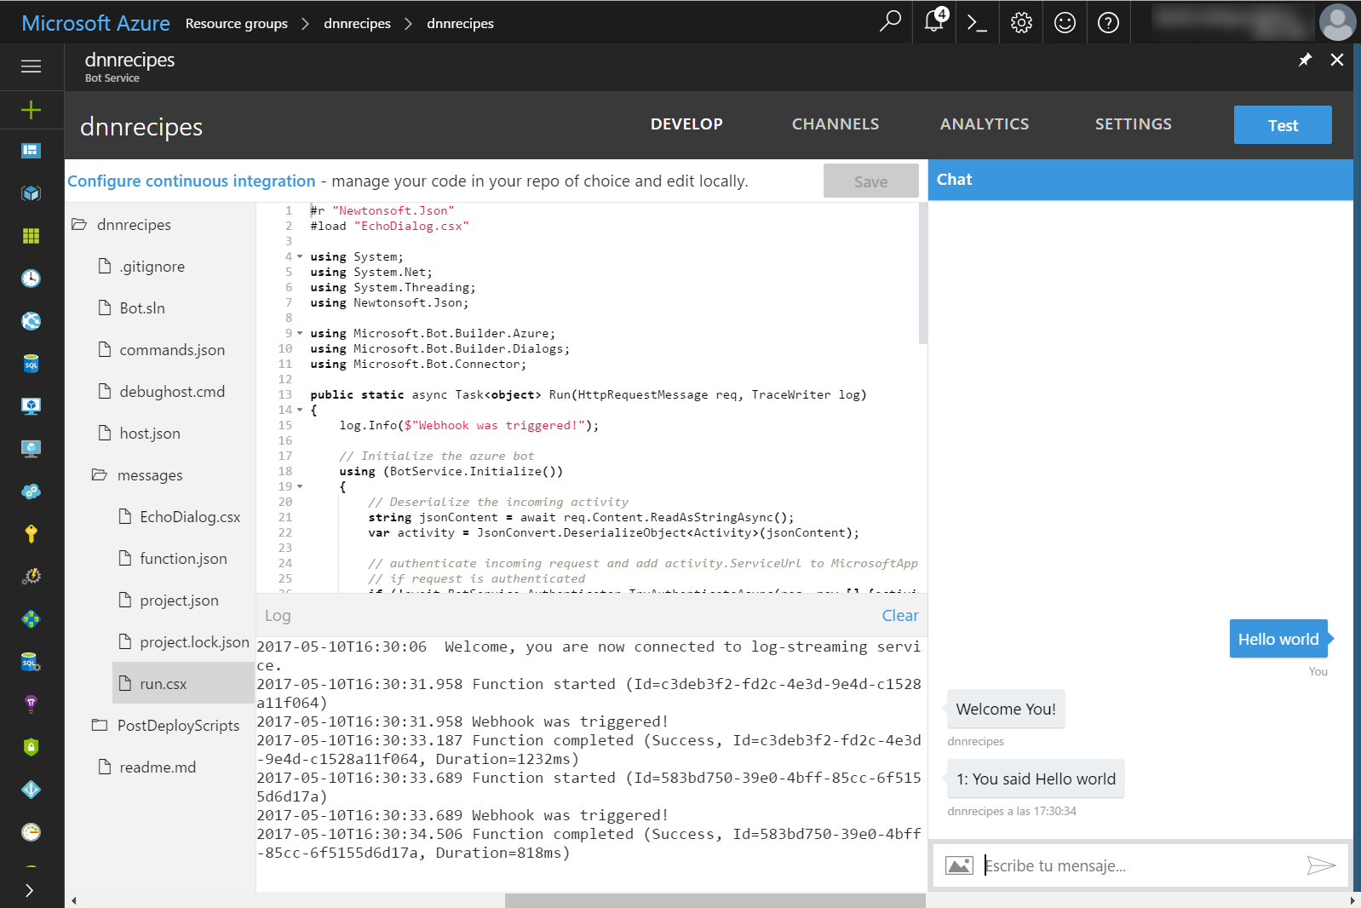

(Note that there may be a slight delay before the splash screen displays indicating that the Bot Service is generating your bot; don’t click **Create bot** again.)

By default, the bot is published on Skype and the web chat is also enabled. For this tutorial, we will use just one of these channels, but feel free to follow the instructions provided on the **Channels** tab to add more channels like Facebook Messenger, Telegram, Microsoft Teams, Slack, etc.

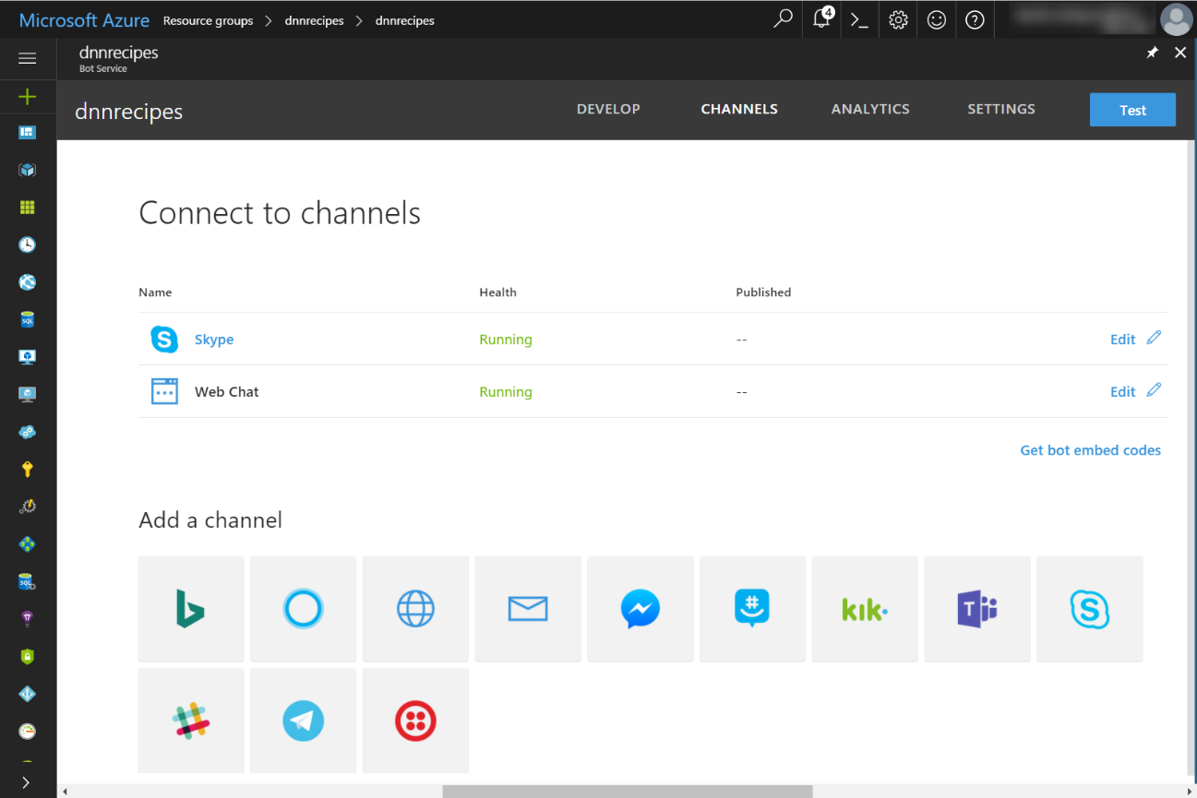

Just to test the default Skype connected channel, click on the **Skype** label to add the Recipe bot you your Skype contacts. You should be able to chat with the bot in the same way you did on the web test pane.

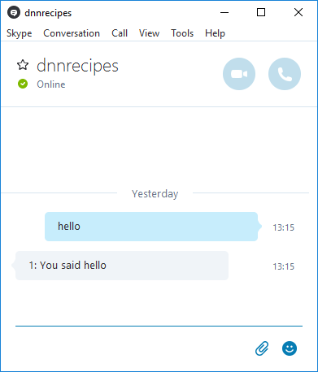

You can find related information about the [Azure Bot service](https://docs.botframework.com/en-us/azure-bot-service/) as part of the Azure Bot Framework SDK documentation.

# Setup continuous integration

By default, Azure Bot Service enables you to develop your bot directly in the browser using the Azure editor, without any need for a local editor or source control. However, Azure editor does not allow you to manage files within your application (e.g., add files, rename files, or delete files). If you want to the ability to manage files within your application, you can set up continuous integration and use the integrated development environment (IDE) and source control system of your choice (e.g., Visual Studio Team, GitHub, Bitbucket). With continuous integration configured, any code changes that you commit to source control will automatically be deployed to Azure. Additionally, you will be able to debug your bot locally if you configure continuous integration.

Note: If you enable continuous integration for your bot, you will no longer be able to edit code in the Azure editor. If you want to edit your code in Azure editor once again, you must [disable continuous integration](https://docs.microsoft.com/es-es/bot-framework/azure/azure-bot-service-continuous-integration" \l "disable-continuous-integration).

For more information, visit [Azure Bot Service continuous integration](https://docs.microsoft.com/es-es/bot-framework/azure/azure-bot-service-continuous-integration).

## Enable continuous integration

You can enable continuous integration for your application by completing three simple steps. Go to **Settings** and scroll down to the **Continuous integration** section. Click on the **Set up integration source** to connect with your repository.

### Create an empty repository within a source control system

First, create an empty repository within one of the source control systems that Azure supports.

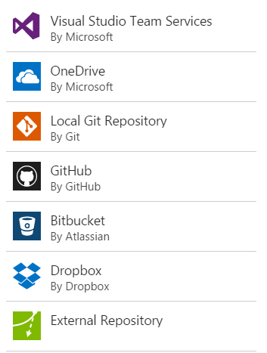

### Download the source code for your bot

Next, download the source code for your bot from the Azure portal to your local working directory.

1. Within your Azure bot, click the **Settings** tab and expand the **Continuous integration** section.
2. Click the link to download the zip file that contains the source code for your bot.

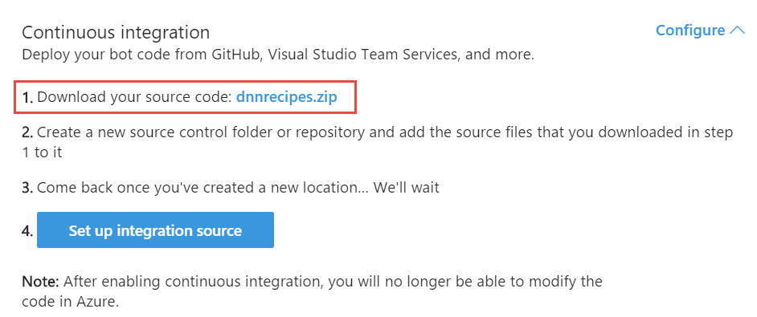

1. Extract the contents of the downloaded zip file to the local folder where you are planning to sync your deployment source.

### Choose the deployment source and connect your repository

Finally, choose the deployment source for your bot and connect your repository.

1. Within your Azure bot, click the **Settings** tab and expand the **Continuous integration** section.
2. Click **Set up integration source**.

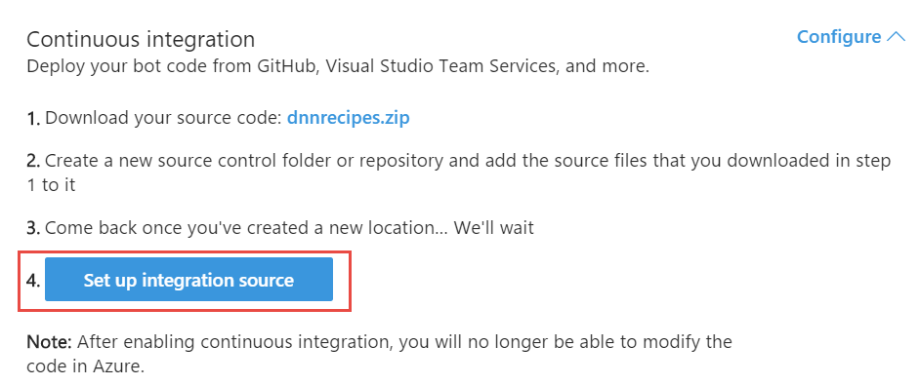

1. Click **Setup**, select the deployment source that corresponds to the source control system where you previously created the empty repository, and complete the steps to connect it. Once setup, you will see the integration details.

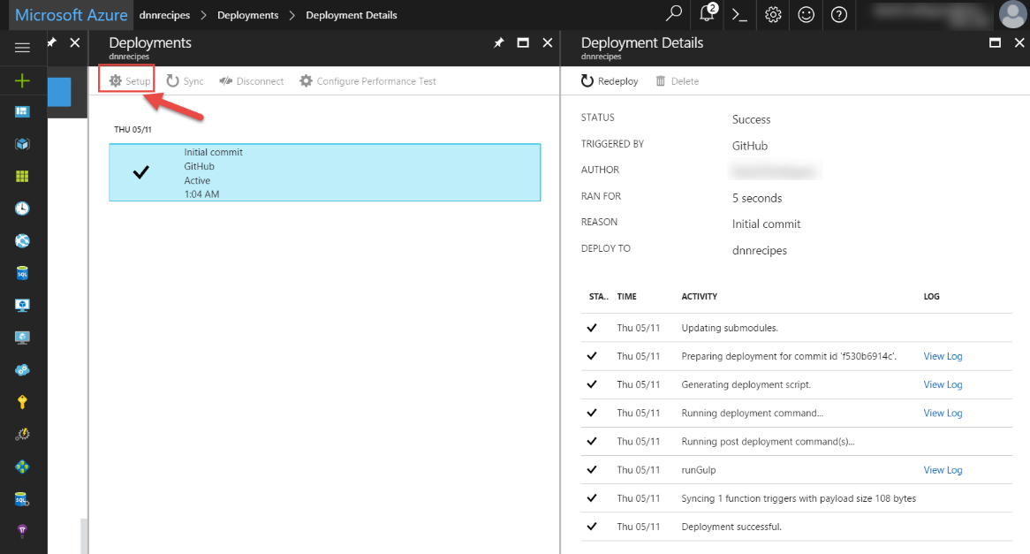

# Debugging the bot on your local environment

Before starting to modify the bot, we would like to setup our local development environment to debug the bot changes, so when we are ready to commit a change, we just push the changes to the repository and the continuous integration will change the Azure Bot service automatically.

Note: the steps outlined here comes from the [Debug a C# bot](https://docs.microsoft.com/es-es/bot-framework/azure/azure-bot-service-debug-bot" \l "a-iddebug-csharpa-debug-a-c-bot) documentation, but with some modification and needed fixes found after the Build 2017 conference.

## Prerequisites

Before you can debug your C# bot, you must complete these tasks.

* Download the source code for your bot (from Azure), as described in **Set up continuous integration** section above.
* Download and install the [Bot Framework Emulator](https://docs.microsoft.com/es-es/bot-framework/debug-bots-emulator).
* Install the [DotNet CLI](https://github.com/dotnet/cli).
* Install the [Azure Functions Core Tools](https://www.npmjs.com/package/azure-functions-core-tools). There is a known issue, and after installing the tools, you must modify the file located at **"%USERPROFILE%\AppData\Roaming\npm\node_modules\azure-functions-cli\bin\Func.exe.config"** and change the System.Net.Http binding redirect as follows. More information on <https://github.com/dotnet/corefx/issues/16805>

<dependentAssembly>

<assemblyIdentity name="System.Net.Http" culture="neutral" publicKeyToken="b03f5f7f11d50a3a" />

<!--Explicitly redirecting back to 4.0.0. See https://github.com/dotnet/corefx/issues/16805 for details-->

<bindingRedirect oldVersion="0.0.0.0-4.1.1.0" newVersion="4.0.0.0" />

</dependentAssembly>

Also, to be able to debug your code by using breakpoints in Visual Studio 2017, you must also complete these tasks.

* Download and install [Visual Studio 2017](https://www.visualstudio.com/downloads/) (Community Edition or above). (VS Code not supported for C# bots yet)
* Download and install the [Command Task Runner Visual Studio Extension](https://visualstudiogallery.msdn.microsoft.com/e6bf6a3d-7411-4494-8a1e-28c1a8c4ce99).

## Debug a C# bot using the Bot Framework Emulator

The simplest way to debug your bot locally is to start the bot and then connect to it from Bot Framework Emulator. First, open a command prompt and navigate to the folder where the **project.json** file is located in your repository. Then, run the command **dotnet restore** to restore the various packages that are referenced in your bot.

1. Visual Studio 2017 RC changes how Visual Studio handles dependencies. While Visual Studio 2015 uses **project.json** to handle dependencies, Visual Studio 2017 uses a .**csproj** model when loading in Visual Studio. If you are using Visual Studio 2017, [download this .csproj file](https://aka.ms/bf-debug-project) to the **/messages** folder in your repository.
2. Also, before executing the dotnet restore, ensure the file messages.csproj you just unzipped, matches the same “Microsoft.Bot.Builder.Azure” version specified on the project.json file. When writing this article, was the 3.2.2.

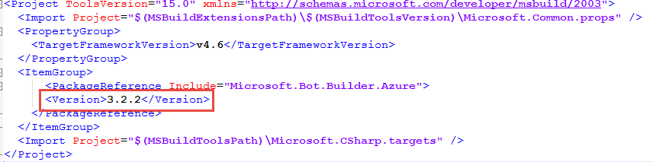

1. Now run the **dotnet restore** command on the /messages folder

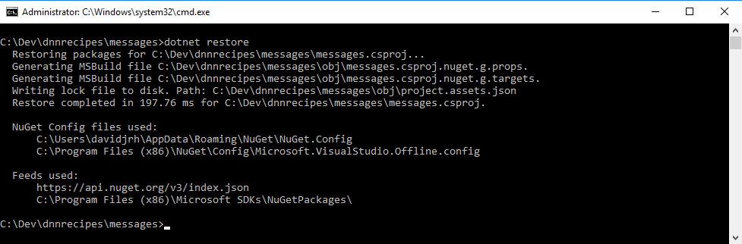

1. Next, run debughost.cmd to load and start your bot

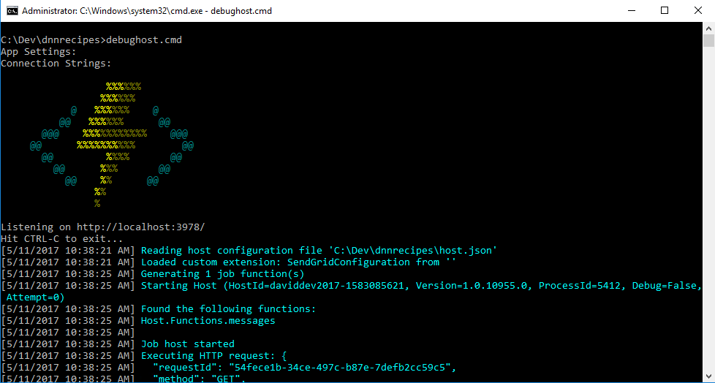

At this point, the bot is running locally. From the console window, copy the endpoint that debughost is listening on (in this example, **http://localhost:3978**). Then, start the Bot Framework Emulator and paste the endpoint into the address bar of the emulator. For this example, you must also append **/api/messages** to the endpoint. Since you do not need security for local debugging, you can leave the **Microsoft App ID** and **Microsoft App Password** fields blank. Click **Connect** to establish a connection to your bot using the specified endpoint.

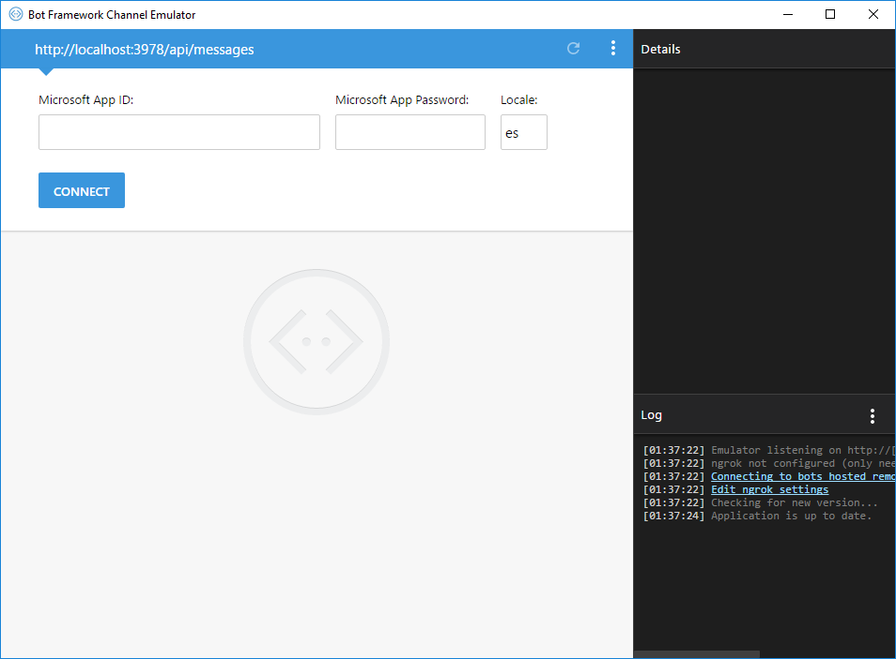

After you have connected the emulator to your bot, send a message to your bot by typing some text into the textbox that is located at the bottom of the emulator window (i.e., where **Type your message**... appears in the lower-left corner). By using the **Log** and **Inspector** panels on the right side of the emulator window, you can view the requests and responses as messages are exchanged between the emulator and the bot.

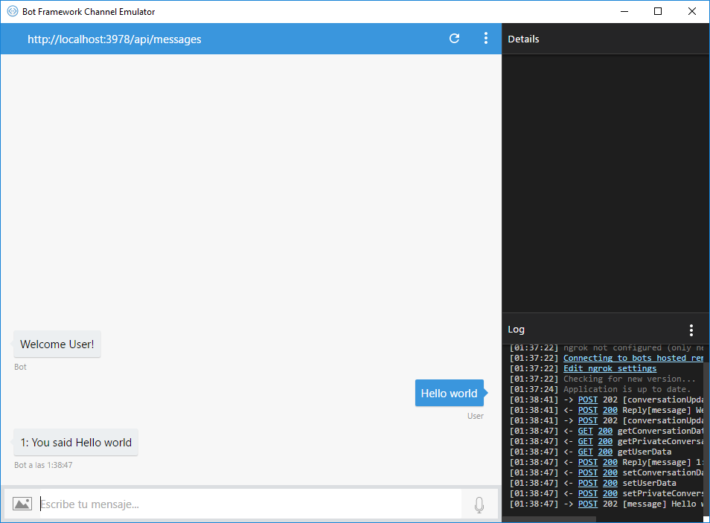

Additionally, you can view log details the console window.

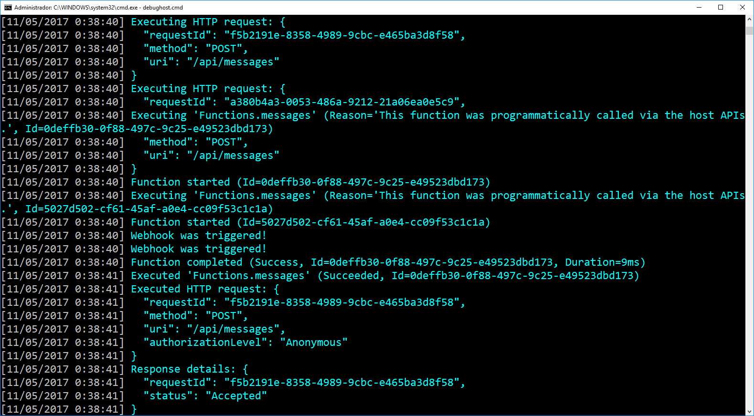

## Debug a C# bot using breakpoints in Visual Studio

To debug your bot using breakpoints in Visual Studio 2017, stop the **DebugHost.cmd** script, and load the solution for your project (included as part of the repository) in Visual Studio. Then, click **Task Runner Explorer** at the bottom of the Visual Studio window.

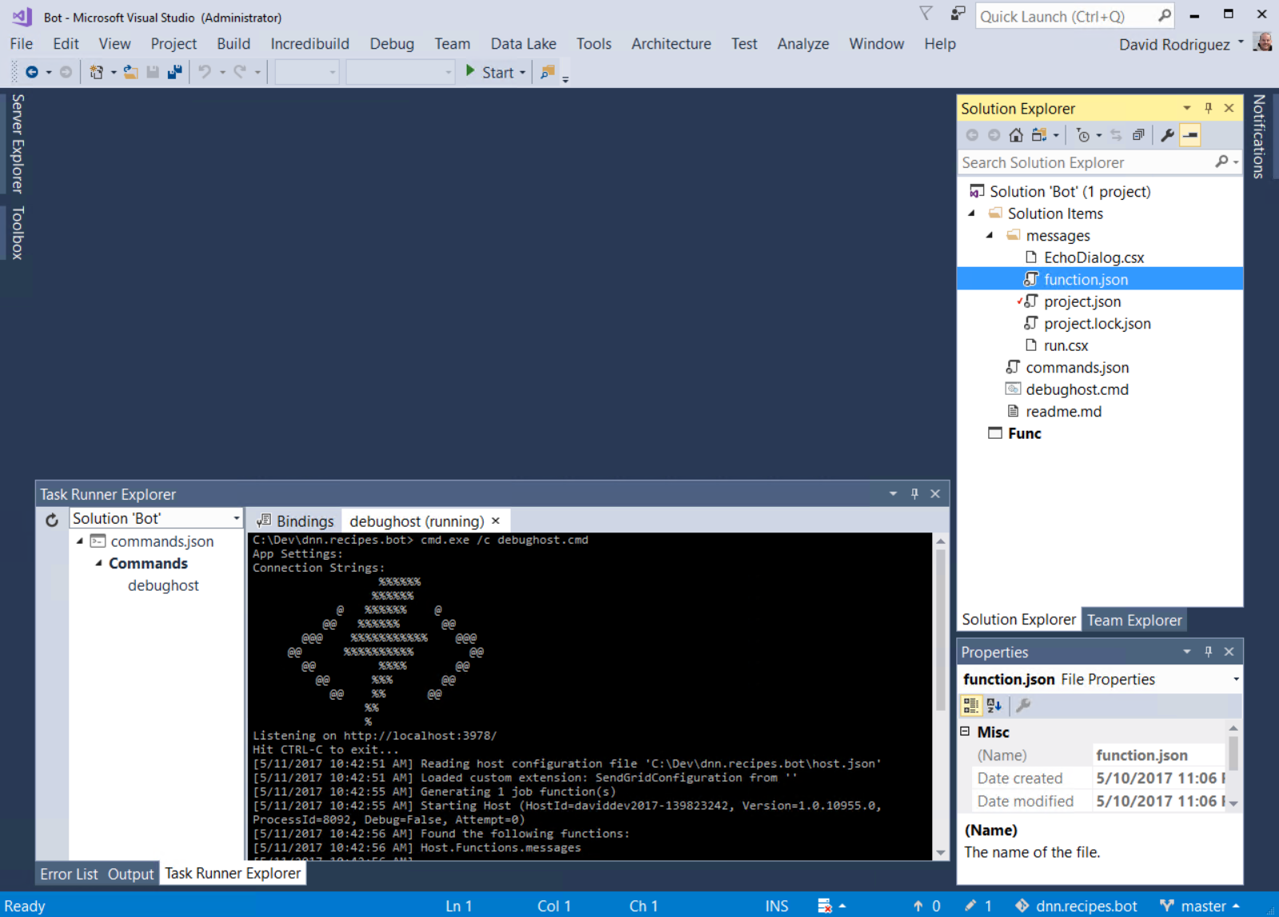

You will see the bot loading in the debug host environment in the **Task Runner Explorer** window. Your bot is now running locally. Copy the bot's endpoint from the **Task Runner Explorer** window, start the Bot Framework Emulator, and paste the endpoint into the address bar of the emulator. For this example, you must also append **/api/messages** to the endpoint. Since you do not need security for local debugging, you can leave the **Microsoft App Id** and **Microsoft App Password** fields blank. Click **Connect** to establish a connection to your bot using the specified endpoint.

After you have connected the emulator to your bot, send a message to your bot by typing some text into the textbox that is located at the bottom of the emulator window (i.e., where **Type your message**... appears in the lower-left corner). As messages are exchanged between the emulator and the bot, you will see the responses as well as logged output within **Task Runner Explorer** in Visual Studio.

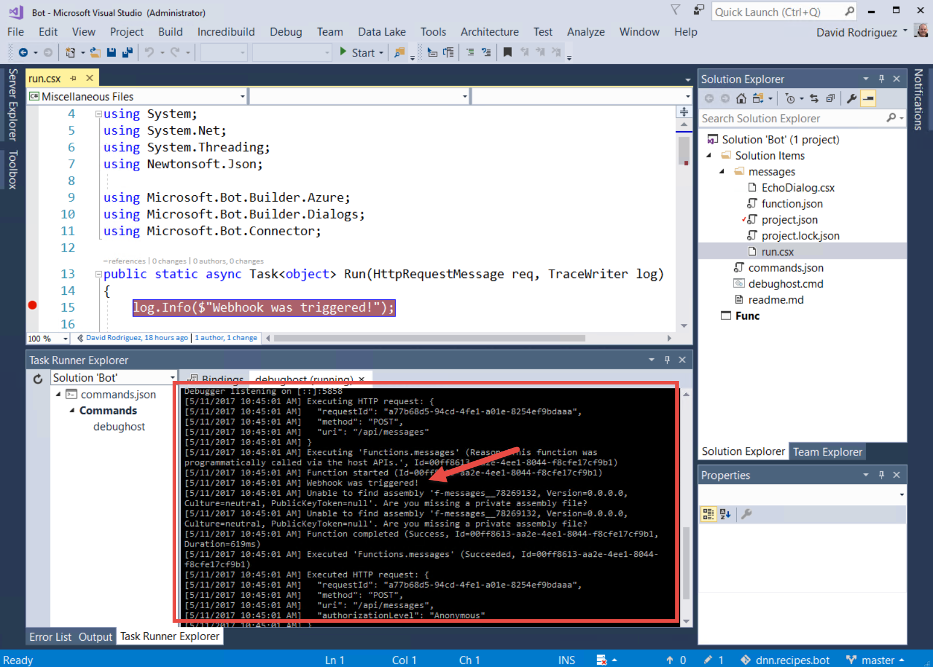

You can also set breakpoints for your bot. The breakpoints are hit only after clicking **Start** in the Visual Studio environment, which will attach to the Azure Function host (**func** command from Azure Functions CLI). Chat with your bot again using the emulator and you should hit the breakpoints that you set in Visual Studio.

Tip: If you cannot successfully set a breakpoint, a syntax error likely exists in your code. To troubleshoot, look for compile errors in the **Task Runner Explorer** window after you try to send messages to your bot.

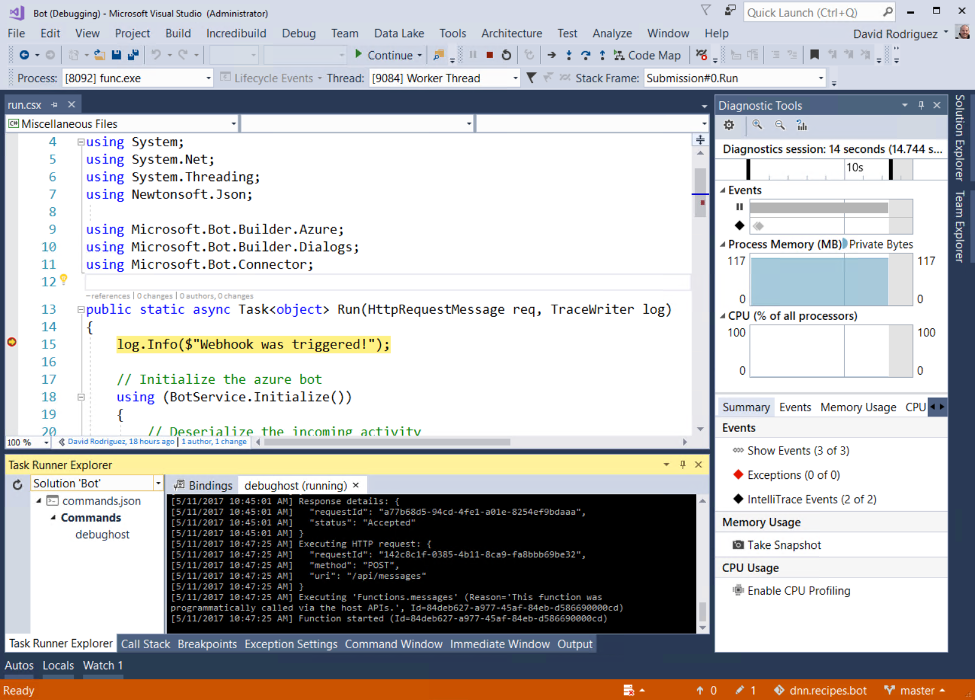

# Customizing the basic bot

We are going to build a very simple bot to start with. The bot will ask you for entering the ingredients you currently have, and the service will return the available recipes containing those ingredients. You can then select a recipe and obtain the cooking instructions. The following diagram shows this simple flow:

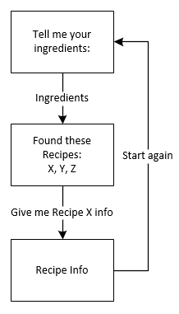

## Modifying the source code

Note that all the code is implemented in [ScriptCS](http://scriptcs.net/), that makes it easy to write and execute C# with a simple text editor. In the next steps, we are going to modify the basic bot source code to implement the recipes bot dialogs.

### Setup the API Key settings

To avoid hardcoding the API Key and the API Endpoint URL on the code, we will set those parameters as application settings

1. On the Azure Portal, open the bot service resource and click on the **Settings** tab
2. Scroll down to the **Application Settings** and click on the **Open** button

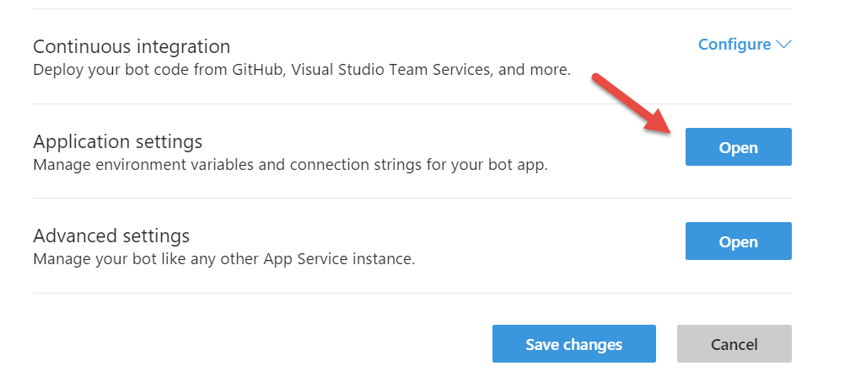

1. Create a new setting named **EvoqAPIEndpoint** with the value <https://dnnapi.com>
2. Create a new setting named **EvoqAPIKey** with the value you obtained on previous steps
3. Click on **Save**

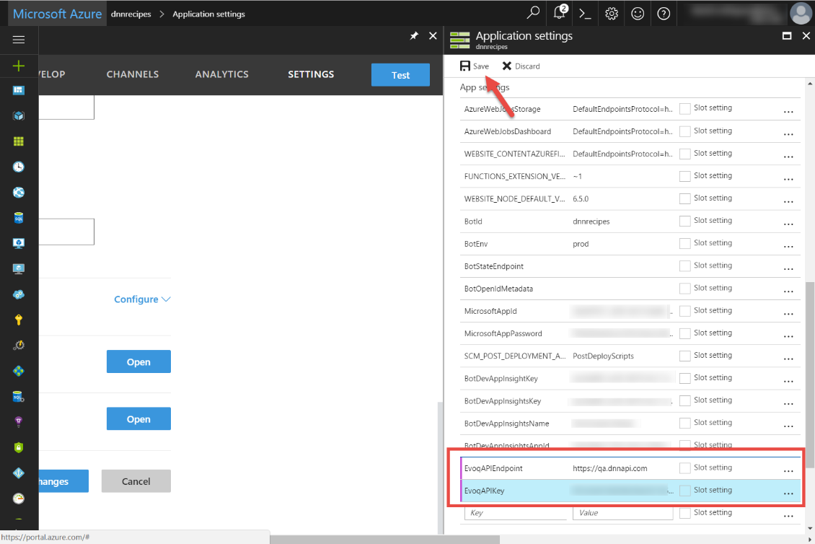

To use these settings on your local environment, follow these steps:

1. Open a command prompt on the root of the source code folder
2. Set the current subscription to the one hosting your bot service with the command **func azure subscription set <subscriptionid>**

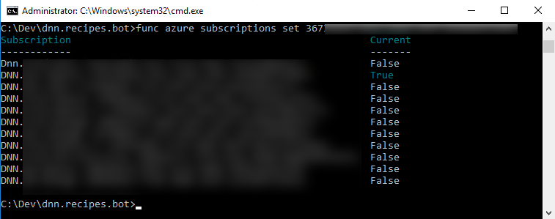

1. Type the command **func azure functionapp fetch-app-settings [YOUR_BOT_SERVICE_NAME]**

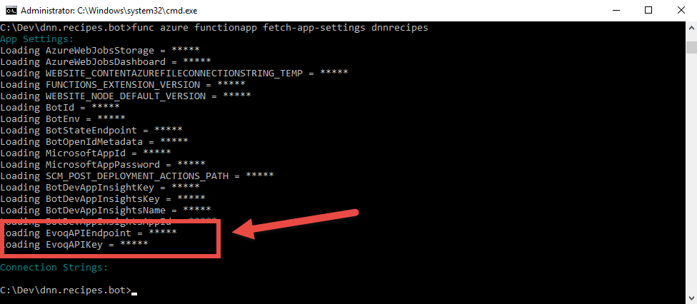

Note that now, when running the bot from both Visual Studio or just starting from the command prompt, the settings are shown at the beginning:

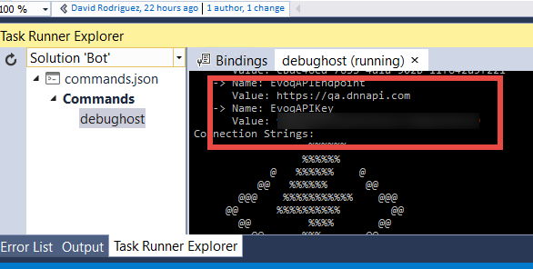

In order to connect from the Bot Emulator to your local bot, you will also need to specify the credentials stored on the app settings **MicrosoftAppId** and **MicrosoftAppPassword:**

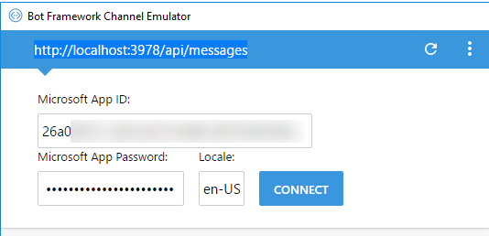

### Adding the RootDialog.csx

To implement the recipes dialogs, let’s do the following changes:

1. Remove the **/messages/EchoDialog.csx** from the solution explorer and delete the file from the file system

NOTE: removing files from the solution explorer doesn’t delete them from the file system. Also, when adding a new file to the solution explorer, ensure that is on the right place by using **Add > Existing item…** dialog instead of **Add > New item… dialog**

1. Add a new text file under the **/messages** folder, called **RootDialog.csx**
2. Modify the **/messages/run.csx** file to delete the reference to the **EchoDialog.csx** and reference now the RootDialog.csx

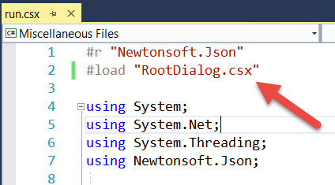

1. Replace the **EchoDialog()** class instantiation for **RootDialog()** class on the **run.csx** file:

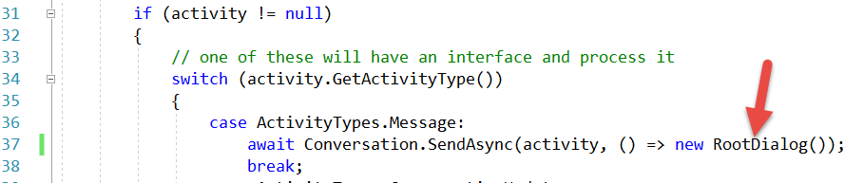

1. Open the **RootDialog.csx** and copy and paste the following code:

|  |
| --- |
| #load ".\Shared\HeroCardExtensions.csx"  #load ".\Shared\Recipes.csx"  #load "RecipeForm.csx"  using System;  using System.Configuration;  using System.Net;  using System.Linq;  using System.Threading.Tasks;  using Microsoft.Bot.Builder.Dialogs;  using Microsoft.Bot.Builder.FormFlow;  using Microsoft.Bot.Connector;  // For more information about this template visit http://aka.ms/azurebots-csharp-basic  [Serializable]  public class RootDialog : IDialog<object>  {  private const string RootDialog_Welcome_Ingredients = "Type ingredients";  private const string RootDialog_Welcome_Ingredients_Picture = "Upload pic of ingredients";  private const string RootDialog_Welcome_Support = "Call DNN Support";  private const string RootDialog_Welcome_Error = "That is not a valid option. Please try again.";  private const string RootDialog_Support_Message = "Support will contact you shortly. Have a nice day :)";  private List<Recipe> Recipes { get; set; }  private RecipeType RecipeType { get; set; }  private static string APIEndpoint => ConfigurationManager.AppSettings["EvoqAPIEndpoint"];  private static string APIKey => ConfigurationManager.AppSettings["EvoqAPIKey"];    public Task StartAsync(IDialogContext context)  {  try  {  context.Wait(MessageReceivedAsync);  }  catch (OperationCanceledException error)  {  return Task.FromCanceled(error.CancellationToken);  }  catch (Exception error)  {  return Task.FromException(error);  }  return Task.CompletedTask;  }  public virtual async Task MessageReceivedAsync(IDialogContext context, IAwaitable<IMessageActivity> argument)  {  var message = await argument;  await this.WelcomeMessageAsync(context);  }  private async Task WelcomeMessageAsync(IDialogContext context)  {  var reply = context.MakeMessage();  var options = new[]  {  RootDialog_Welcome_Ingredients,  RootDialog_Welcome_Ingredients_Picture,  RootDialog_Welcome_Support  };  HeroCardExtensions.AddHeroCard(ref reply,  "Recipes Bot",  "Your agent that allows you to cook Liquid Content recipes",  options,  new[] { "https://raw.githubusercontent.com/davidjrh/dnn.recipes.bot/master/dnnrecipes.jpg" });  await context.PostAsync(reply);  context.Wait(this.OnOptionSelected);  }  private async Task OnOptionSelected(IDialogContext context, IAwaitable<IMessageActivity> result)  {  var message = await result;  if (message.Text == RootDialog_Welcome_Ingredients)  {  context.Call(RecipeForm.BuildFormDialog(FormOptions.PromptInStart), FormComplete);  }  else if (message.Text == RootDialog_Welcome_Ingredients_Picture)  {  await context.PostAsync("This will be on the second tutorial using **Cognitive Services**. Come back soon!");  context.Wait(MessageReceivedAsync);  }  else if (message.Text == RootDialog_Welcome_Support)  {  await context.PostAsync("Support will contact you shortly. Have a nice day :)");  context.Wait(MessageReceivedAsync);  }  else  {  await this.StartOverAsync(context, RootDialog_Welcome_Error);  }  }  private async Task FormComplete(IDialogContext context, IAwaitable<RecipeForm> result)  {  try  {  var form = await result;  if (form != null)  {  await context.PostAsync("Ok. Give me a second while I look for something tasty...");  if (this.RecipeType == null)  {  this.RecipeType = await GetRecipeTypeAsync();  }  this.Recipes = await GetRecipesAsync(form.Ingredients, this.RecipeType);  if (this.Recipes != null && this.Recipes.Count > 0)  {  await this.ShowRecipesAsync(context);  }  else  {  await context.PostAsync("Sorry, seems there are no recipes in my library for those ingredients! Do you want me to order a pizza?");  context.Wait(MessageReceivedAsync);  }  }  else  {  await context.PostAsync("Form returned empty response! Type anything to restart it.");  context.Wait(MessageReceivedAsync);  }  }  catch (OperationCanceledException)  {  await context.PostAsync("You canceled the form! Type anything to restart it.");  context.Wait(MessageReceivedAsync);  }    }  protected async Task ShowRecipesAsync(IDialogContext context)  {  await context.PostAsync($"Found {this.Recipes.Count} recipes:");  var carouselCards = this.Recipes.Select(it => new HeroCard  {  Title = it.Name,  Text = it.Description,  Images = new List<CardImage> {  new CardImage(string.IsNullOrEmpty(it.Details.ImageUrl) ?  "https://raw.githubusercontent.com/davidjrh/mytrash/master/no-image-icon.png" :  it.Details.ImageUrl, it.Name)  },  Buttons = new List<CardAction>  {  new CardAction(ActionTypes.ImBack, "Select", value: it.Name)  }  });  var reply = context.MakeMessage();  reply.AttachmentLayout = AttachmentLayoutTypes.Carousel;  reply.Attachments = new List<Attachment>();  foreach (var card in carouselCards)  {  reply.Attachments.Add(card.ToAttachment());  }  await context.PostAsync(reply);  context.Wait(this.OnRecipeSelected);  }  private async Task OnRecipeSelected(IDialogContext context, IAwaitable<IMessageActivity> result)  {  var message = await result;  var recipe = this.Recipes.FirstOrDefault(x => x.Name == message.Text);  if (recipe != null)  {  await context.PostAsync($"**{recipe.Name.ToUpperInvariant()}**");  await context.PostAsync(recipe.Description);  await context.PostAsync($"**Ingredients**: {recipe.Details.Ingredients}");  await context.PostAsync($"**Instructions**: {recipe.Details.Instructions}");  }  else  {  await this.StartOverAsync(context, "That recipe is not an option");  }  }  static public async Task<List<Recipe>> GetRecipesAsync(string ingredients, RecipeType recipeType)  {  if (recipeType == null) return null;  var parsedIngredients = ParseIngredients(ingredients);  var request = (HttpWebRequest)WebRequest.Create(  $"{APIEndpoint}/content/api/contentitems?contenttypeid={recipeType.Id}&searchtext={WebUtility.UrlEncode(parsedIngredients)}");  request.Method = "GET";  request.ContentType = "application/json";  request.Headers = new WebHeaderCollection();  request.Headers.Add("Authorization", $"Bearer {APIKey}");  using (var response = await request.GetResponseAsync() as HttpWebResponse)  {  if (response.StatusCode != HttpStatusCode.OK)  throw new Exception($"Server error (HTTP {response.StatusCode}: {response.StatusDescription}).");  using (Stream stream = response.GetResponseStream())  using (StreamReader streamReader = new StreamReader(stream))  {  var strsb = await streamReader.ReadToEndAsync();  var items = Newtonsoft.Json.JsonConvert.DeserializeObject<RecipesCollection>(strsb);  if (items != null && items.Recipes != null)  return items.Recipes;  return null;  }  }  }  static public async Task<RecipeType> GetRecipeTypeAsync()  {  var request = (HttpWebRequest)WebRequest.Create(  $"{APIEndpoint}/content/api/contenttypes?searchtext=recipe");  request.Method = "GET";  request.ContentType = "application/json";  request.Headers = new WebHeaderCollection();  request.Headers.Add("Authorization", $"Bearer {APIKey}");  using (var response = await request.GetResponseAsync() as HttpWebResponse)  {  if (response.StatusCode != HttpStatusCode.OK)  throw new Exception($"Server error (HTTP {response.StatusCode}: {response.StatusDescription}).");  using (Stream stream = response.GetResponseStream())  using (StreamReader streamReader = new StreamReader(stream))  {  var strsb = await streamReader.ReadToEndAsync();  var items = Newtonsoft.Json.JsonConvert.DeserializeObject<RecipeTypesCollection>(strsb);  if (items != null && items.RecipeTypes != null)  return items.RecipeTypes.FirstOrDefault();  return null;  }  }  }  private static string ParseIngredients(string ingredients)  {  var ignoreList = new string[] { "and", "or" };  var list = ingredients.Trim().Replace(".", ",").Replace(" ", ",").Split(',');  return String.Join("+", list.Where(x => !string.IsNullOrEmpty(x) && !ignoreList.Contains(x)));  }  private async Task StartOverAsync(IDialogContext context, string text)  {  var message = context.MakeMessage();  message.Text = text;  await this.StartOverAsync(context, message);  }  private async Task StartOverAsync(IDialogContext context, IMessageActivity message)  {  await context.PostAsync(message);  //this.order = new Models.Order();  await this.WelcomeMessageAsync(context);  }  } |

### Adding the HeroCardExtensions.csx

1. Create the folder **/messages/Shared**.
2. To Ensure that when the files under that directory change your functions will pick up the changes and be recompiled, add the “Shared” directory to the **watchDirectories** list in the **host.json**

{

"watchDirectories": [ "Shared" ]

}

1. Create a new text file **/messages/Shared**/**HeroCardExtensions.csx** and add it to the solution explorer.
2. Open the **HeroCardExtensions.csx** and copy and paste the following code:

|  |
| --- |
| using System.Collections.Generic;  using System.Linq;  using Microsoft.Bot.Connector;  public static class HeroCardExtensions  {  public static void AddHeroCard<T>(ref IMessageActivity message, string title, string subtitle, IEnumerable<T> options, IEnumerable<string> images = default(IEnumerable<string>))  {  var heroCard = GenerateHeroCard(title, subtitle, options, images);  if (message.Attachments == null)  {  message.Attachments = new List<Attachment>();  }  message.Attachments.Add(heroCard.ToAttachment());  }  public static void AddHeroCard(ref IMessageActivity message, string title, string subtitle, IList<KeyValuePair<string, string>> options, IEnumerable<string> images = default(IEnumerable<string>))  {  var heroCard = GenerateHeroCard(title, subtitle, options, images);  if (message.Attachments == null)  {  message.Attachments = new List<Attachment>();  }  message.Attachments.Add(heroCard.ToAttachment());  }  private static HeroCard GenerateHeroCard(string title, string subtitle, IEnumerable<KeyValuePair<string, string>> options, IEnumerable<string> images)  {  var actions = new List<CardAction>();  foreach (var option in options)  {  actions.Add(new CardAction  {  Title = option.Key.ToString(),  Type = ActionTypes.ImBack,  Value = option.Value.ToString()  });  }  var cardImages = new List<CardImage>();  if (images != default(IEnumerable<string>))  {  foreach (var image in images)  {  cardImages.Add(new CardImage  {  Url = image,  });  }  }  return new HeroCard(title, subtitle, images: cardImages, buttons: actions);  }  private static HeroCard GenerateHeroCard<T>(string title, string subtitle, IEnumerable<T> options, IEnumerable<string> images)  {  return GenerateHeroCard(title, subtitle, options.Select(option => new KeyValuePair<string, string>(option.ToString(), option.ToString())), images);  }  } |

### Adding the Recipes.csx

1. Create a new text file **/messages/Shared**/**Recipes.csx** and add it to the solution explorer.
2. Open the **Recipes.csx** and copy and paste the following code:

|  |
| --- |
| using Newtonsoft.Json;  [Serializable]  public class RecipesCollection  {  [JsonProperty(PropertyName = "documents")]  public List<Recipe> Recipes { get; set; }  }  [Serializable]  public class RecipeTypesCollection  {  [JsonProperty(PropertyName = "documents")]  public List<RecipeType> RecipeTypes { get; set; }  }  [Serializable]  public class RecipeType  {  [JsonProperty(PropertyName = "id")]  public string Id { get; set; }  [JsonProperty(PropertyName = "name")]  public string Name { get; set; }  }  [Serializable]  public class Recipe  {  [JsonProperty(PropertyName = "id")]  public string Id { get; set; }  [JsonProperty(PropertyName = "name")]  public string Name { get; set; }  [JsonProperty(PropertyName = "description")]  public string Description { get; set; }  [JsonProperty(PropertyName = "details")]  public RecipeDetails Details { get; set; }  [JsonProperty(PropertyName = "updatedAt")]  public DateTime UpdatedAt { get; set; }  [JsonProperty(PropertyName = "updatedBy")]  public RecipeAuthor Author { get; set; }  }  [Serializable]  public class RecipeDetails  {  [JsonProperty(PropertyName = "name")]  public string Name { get; set; }  [JsonProperty(PropertyName = "ingredients")]  public string Ingredients { get; set; }  [JsonProperty(PropertyName = "instructions")]  public string Instructions { get; set; }  //[JsonProperty(PropertyName = "recipeType")]  //public string RecipeType { get; set; }  [JsonProperty(PropertyName = "pictureUrl")]  public string ImageUrl { get; set; }  }  [Serializable]  public class RecipeAuthor  {  [JsonProperty(PropertyName = "name")]  public string Name { get; set; }  [JsonProperty(PropertyName = "thumbnail")]  public string ProfilePictureUrl { get; set; }  } |

### Adding the RecipeForm.csx

1. Create a new text file **/messages/RecipeForm.csx** and add it to the solution explorer.
2. Open the **RecipeForm.csx** and copy and paste the following code:

|  |
| --- |
| using System;  using Microsoft.Bot.Builder.FormFlow;  public enum RecipeTypeEnum { Starters = 1, Breakfast, Salads, Soups, MainCourses, Sides, Desserts, All };  // For more information about this template visit http://aka.ms/azurebots-csharp-form  [Serializable]  public class RecipeForm  {  [Prompt("Which {&} do you have?")]  public string Ingredients { get; set; }  [Prompt("Please select the type of recype you want to cook {||}")]  public RecipeTypeEnum RecypeType { get; set; }  public static IForm<RecipeForm> BuildForm()  {  // Builds an IForm<T> based on BasicForm  return new FormBuilder<RecipeForm>().Build();  }  public static IFormDialog<RecipeForm> BuildFormDialog(FormOptions options = FormOptions.PromptInStart)  {  // Generated a new FormDialog<T> based on IForm<BasicForm>  return FormDialog.FromForm(BuildForm, options);  }  } |

# Test your Recipes bot

## Test your bot locally

Now that you have all the code, start the command prompt **debughost.cmd** and target your Bot Emulator to your local endpoint, or if you prefer to debug, open Visual Studio and run the Task Runner Explorer as shown in the “Debug in your local environment” section.

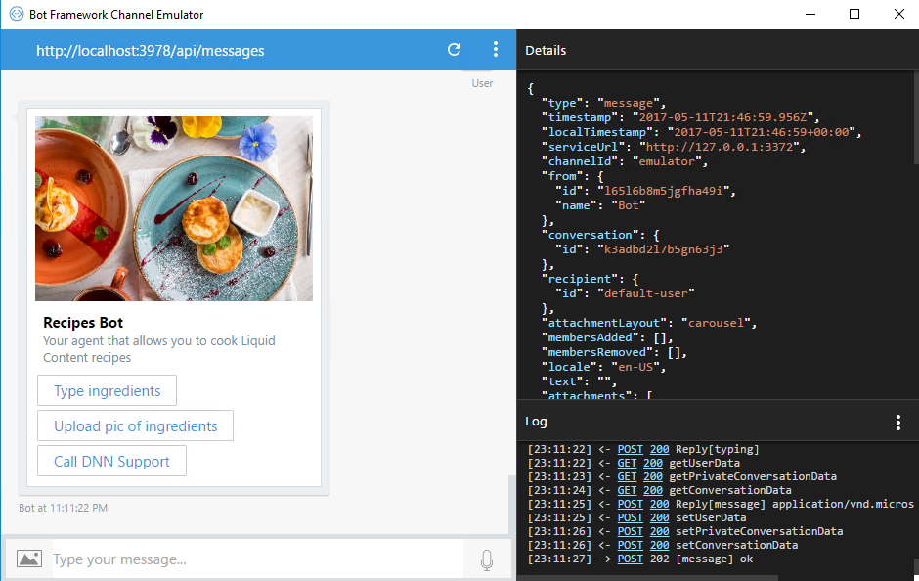

**IMPORTANT: Once you are done, don’t forget to commit the changes in your repository to allow the source control integration to publish your bot automatically on Azure.**

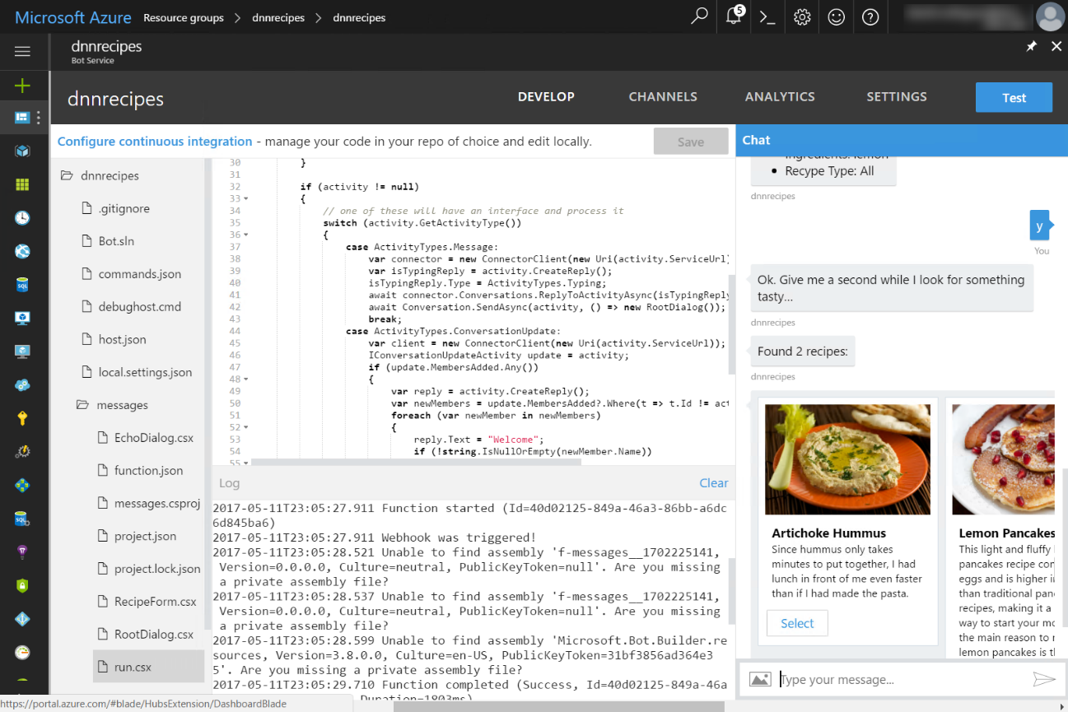

## Test from other channels

Now is time to play with other channels. You can find more information at <https://docs.microsoft.com/en-us/bot-framework/portal-configure-channels>

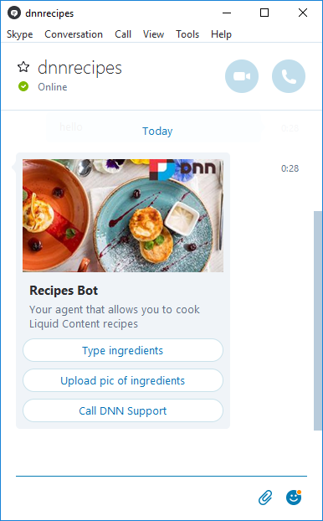

# Adding a webchat in your site

One of the default channels shared by the Azure Bot service is a webchat. Follow these steps to easily integrate the webchat just by using a new Bot Visualizer.

## Enable your bot webchat

1. On the Azure Portal, open your bot’s **Channels** tab and click on the **Web Chat** edit button to edit the properties

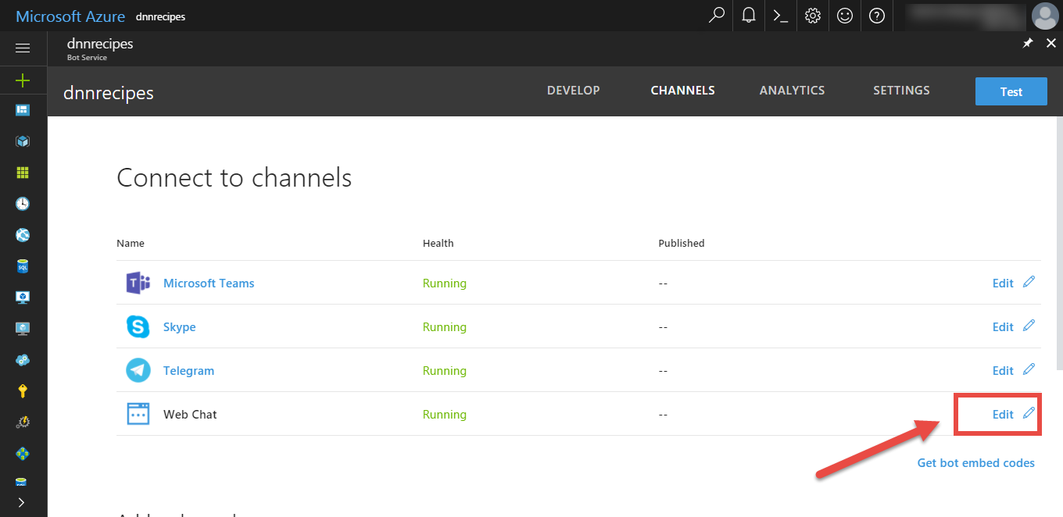

1. Click on the **Add new site** button to generate a secret key for your web chat

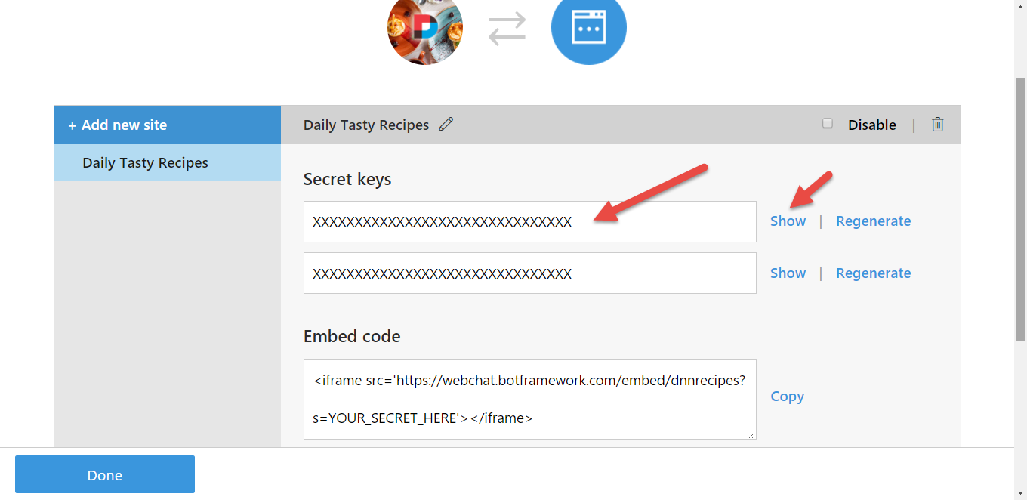

1. Copy the secret key in a secure place, you will be using it when setting up the bot
2. Click on **Done** to save the changes

## Create a webchat bot content type

1. Back in your website, create a new content type with the following fields:

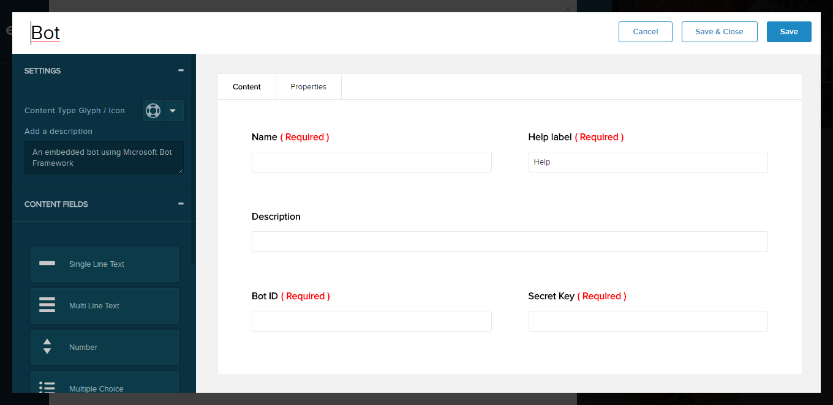

* + Name: Single Line Text (Required)
  + Help label: Single Line Text (Required)
  + Description: Single Line Text
  + Bot ID: Single Line Text (Required)
  + Script Key: Single Line Text (Required)

1. Click on **Save and close**

## Create a bot content item

1. Create a new content item of type **Bot**
2. Type the name of your bot as appears on the Azure Portal
3. Copy and paste on the Bot ID available on the Settings tab of your bot

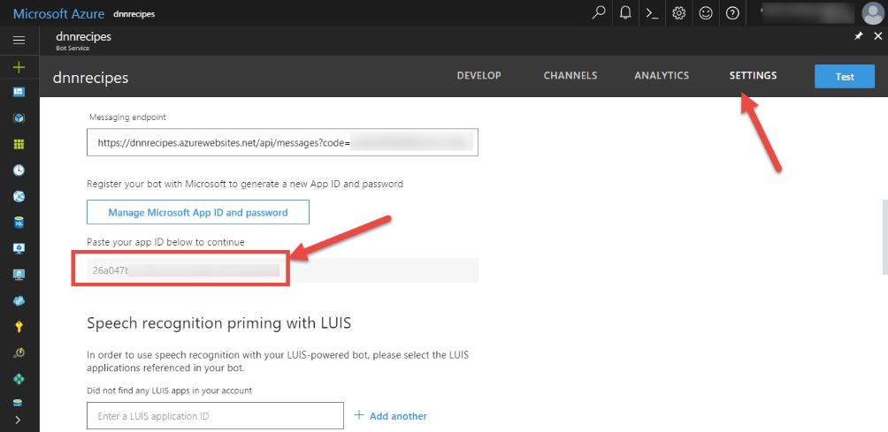

1. Copy and paste the webchat secret key you generated before

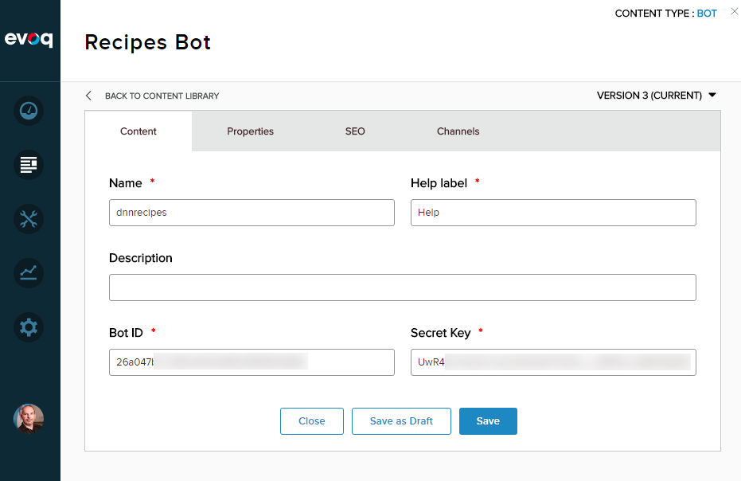

1. Click on **Save** to save the bot

## Create a bot visualizer

1. Create a new visualizer called **Embedded bot helper** of content type **Bot**
2. On the **Script** tab, paste the following

|  |
| --- |
| var dnnBot = dnnBot || {  showTab: function () {  $('.bot-tab').removeClass('bot-tab-hide');  },  hideTab: function () {  $('.bot-tab').addClass('bot-tab-hide');  },  showChat: function () {  $('.bot-chat').addClass('bot-chat-show');  },  hideChat: function () {  $('.bot-chat').removeClass('bot-chat-show');  }  };  jQuery(function () {  $('.bot-tab').click(function () {  dnnBot.hideTab();  setTimeout('dnnBot.showChat()', 200);  });  $('.bot-close').click(function () {  dnnBot.hideChat();  setTimeout('dnnBot.showTab()', 300);  });  }); |

1. On the **Styles** tab, paste the following

|  |
| --- |
| .bot-tab {  border-radius: 5px 5px 0 0;  height: 40px;  padding: 0;  background-color: #402A2E;  color: #fff;  position: fixed;  z-index: 9999;  cursor: pointer;  left: auto;  right: 0;  -moz-transform: rotate(-90.0deg);  -ms-transform: rotate(-90.0deg);  -o-transform: rotate(-90.0deg);  -webkit-transform: rotate(-90.0deg);  transform: rotate(-90.0deg);  margin-right: -19px;  border: 2px solid #fff;  box-shadow: 0 0 5px 0 rgba(0, 0, 0, 0.5);  -moz-transition: margin-right .2s ease-in;  -o-transition: margin-right .2s ease-in;  -webkit-transition: margin-right .2s ease-in;  transition: margin-right .2s ease-in;  top: 150px;  }  .bot-tab-hide {  margin-right: -75px;  }  .bot-tab-icon {  background: transparent url(https://raw.githubusercontent.com/davidjrh/dnn.bot/master/Dnn.Bot/images/bot-icon.png) no-repeat center;  float: left;  height: 100%;  width: 35px;  }  .bot-tab-title {  float: right;  font-size: 13px;  font-weight: bold;  line-height: 18px;  padding: 10px 10px 10px 0;  }  .bot-chat {  position: fixed;  right: 0;  left: auto;  top: 0;  bottom: 0;  z-index: 9999;  box-shadow: 0 0 5px 0 rgba(0, 0, 0, 0.5);  margin-right: -350px;  -moz-transition: margin-right .3s ease-in;  -o-transition: margin-right .3s ease-in;  -webkit-transition: margin-right .3s ease-in;  transition: margin-right .3s ease-in;  background-color: white;  }  .bot-chat > iframe {  height: 100%;  width: 350px;  }  .bot-chat-show {  margin-right: 0;  }  .bot-close {  position: absolute;  top: 5px;  right: 5px;  width: 35px;  height: 30px;  z-index: 99999;  background: transparent url(https://raw.githubusercontent.com/davidjrh/dnn.bot/master/Dnn.Bot/images/close.png) no-repeat center;  cursor: pointer;  } |

1. On the **Template** tab, paste the following

|  |
| --- |
| <div id="HelpBot">  <div class="bot-tab">  <div class="bot-tab-icon"></div>  <div class="bot-tab-title">{{helpLabel}}</div>  </div>  <div class="bot-chat">  <div class="bot-close"></div>  <div style="padding-top: 7px; padding-left: 5px; position: absolute;"><a href="https://join.skype.com/bot/{{botID}}"><img alt="" src="https://dev.botframework.com/Client/Images/Add-To-Skype-Buttons.png" /></a></div>  <iframe src="https://webchat.botframework.com/embed/{{name}}?s={{secretKey}}"></iframe>  </div>  </div> |

## Add the visualizer to a page

1. Edit a page in your site to add a visualizer
2. From the list of visualizers, select the **Embedded Bot Helper**
3. From the bots list, select the bot you have created
4. Click OK and save the changes

After refreshing the page, a Button on the right side should appear to open the webchat.

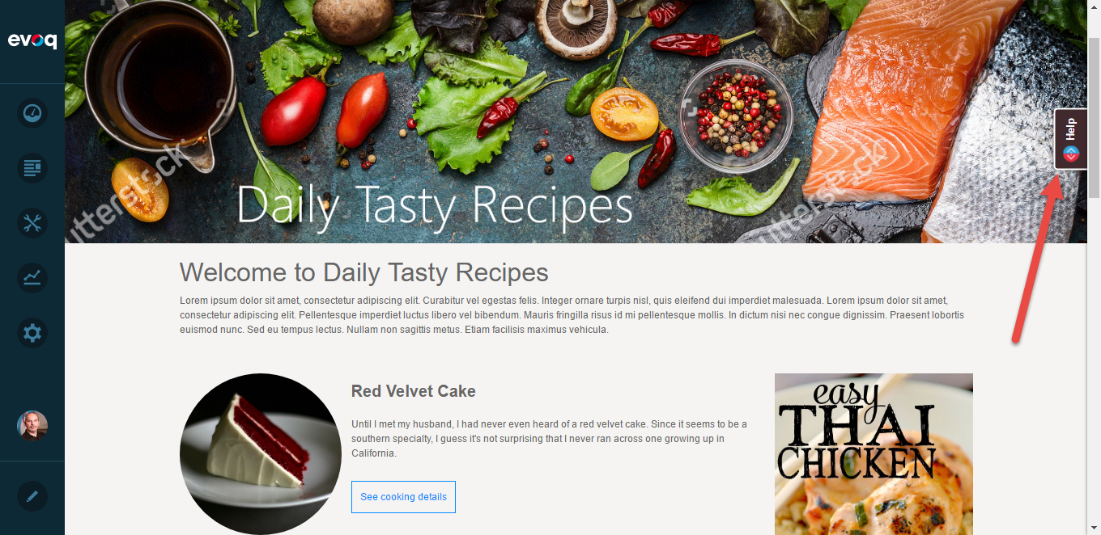

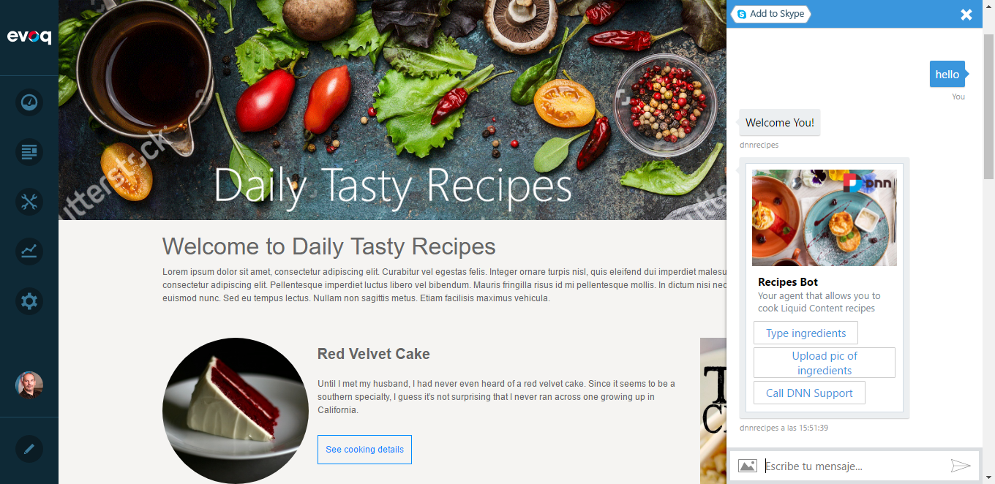

# Known issues

**Inheritance security rules violated by type: 'System.Net.Http.WebRequestHandler'. Derived types must either match the security accessibility of the base type or be less accessible**

Edit the file "%USERPROFILE%\AppData\Roaming\npm\node_modules\azure-functions-cli\bin\Func.exe.config" and change the binding redirect as follows. More information on <https://github.com/dotnet/corefx/issues/16805>

<dependentAssembly>

<assemblyIdentity name="System.Net.Http" culture="neutral" publicKeyToken="b03f5f7f11d50a3a" />

<!--Explicitly redirecting back to 4.0.0. See https://github.com/dotnet/corefx/issues/16805 for details-->

<bindingRedirect oldVersion="0.0.0.0-4.1.1.0" newVersion="4.0.0.0" />

</dependentAssembly>